FROM THE BAND ROOM TO THE BOARDROOM…The Nine Lessons of Music Education that Translate into Business Success

by Craig M. Cortello
(The following article is an excerpt from Everything We Needed to Know About Business, We Learned Playing Music, printed with permission from the author. The book is a compilation of 32 profiles of CEOs and business professionals who played music as a child or adolescent and view that experience as a defining one in preparing them for success in their business endeavors.)

These are alarming times for the plight of music education funding. Economic downturns are an immediate sign of crisis for those programs that have perennially been at or near the education budgetary chopping block. Non-profit organizations that try to fill that resource gap often rely on the benevolence of those impacted by an ailing economy. Perhaps a new understanding of the transcendent lessons of a music education can lead to a reshuffling of education priorities.

Consider a conversation that I had a couple of years ago with Ellis Marsalis, Jr., modern jazz pioneer, music educator, and the father of the first family of jazz in New Orleans and beyond.

“To me there’s nothing wrong with somebody who has played a musical instrument and is not going to do it for a living becoming the CEO of a major corporation, and there’s a ton of that,” said Marsalis. “I met a guy at Merrill Lynch who’s a clarinet player. One of the best pianists we had, a young lady at NOCCA when I was teaching there – She’s a banker in New Jersey” (NOCCA refers to the New Orleans Center for Creative Arts, an advanced program for young prodigies of music and the arts for high school-aged youths in New Orleans).

Ellis Marsalis, Jr. understood that regardless of whether the ultimate vocation of the students that came under his tutelage (including his children) turned out to be trumpet, saxophone, trombone, percussion, or banking and financial services, music education could comprise an integral component of the foundation for their success. As he explained, it’s only one element, but an important one in a well-rounded education that prepares a student for a diversified world and uncertain times.

Researching the Business Correlation of Music Education
For a period of 18 months I discussed this subject with 32 CEO’s and business leaders from around the country (and a few from beyond). The task was to identify successful people from a cross-section of business who were influenced by music education as a child or adolescent and who view that experience as a defining one in preparing them for success in their business endeavors. I asked them to reflect and to articulate the lessons learned, attributes developed, and insights gained from their music experience that were highly correlative to success in the business world, “from the band room to the boardroom,” so to speak. Here are the nine common lessons articulated by the research participants.

Confidence and Self-Esteem (Stepping Up to the Mic)
One of the most common benefits of music expressed by our research subjects was the development of confidence and self-esteem. Consistently, I heard our contributors speak of the positive effect that performing in front of an audience, mastering a new musical piece, or simply connecting with other musicians in an ensemble had on building their ability to believe in themselves and perform under pressure.

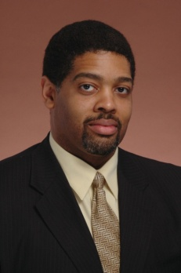“Courage is realizing your fear and going ahead and doing what you should do. So for me, realizing that I had stage fright, the confidence builder was that I did it. I was supposed to get up and do a solo, and I actually finished. That built the confidence. Something that I was terrified to do, I could prepare to do it and do it well, despite being afraid.”

“As a surgeon there are lots of times when you make your incision, and it’s a lot more challenging than you thought it would be…That experience helped me in terms of training me that when you get a little nervous, to use that energy to perfect your performance rather than fall apart.”
H. Steven Sims, M.D. Director, Chicago Institute for Voice Care
Assistant Professor, University of Illinois at Chicago Medical Center
Vocalist, Pianist, Trombonist, & Bassoonist

Collaboration and Teamwork (I’m in the Band)
There’s a certain give and take that comes from playing in a band where you have to assess the strengths, weaknesses, and personalities of the members of the team. Fitting the complex pieces of that puzzle in a way that makes the music come together is quite an art. Those skills translate well to business endeavors or projects that involve teamwork and collaboration.

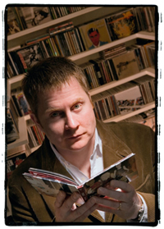“In five minutes, I’m going to walk into a room to talk about a multi-million dollar RFP (Request for Proposal). I’m going to go in there with an idea or two or three or four, and I’m going to sit down with other senior people in the firm. As if we were a jazz combo, we’re going to just start riffing off of one another, and we’re going to find a rhythm – a creative, strategic rhythm. And then we’re going to come out with some really good ideas.”

“I don’t want to belabor the parallel, but when you have people who speak the same language, musical language or intellectual language, people who have similar skill sets and traits and talents, and you bring them together with a common purpose, good things often happen.”

Bob Knott
Executive Vice-President
Edelman Group
(Global Independent Public Relations Firm)
Guitarist, Music Critic

Leadership (Conducting Your Symphony of Employees)
The application of the competencies of teamwork and collaboration takes on new meaning from the perspective of a leader. A conductor must understand the strengths of all of the musicians, understanding how their skills fit into the big picture of the orchestra. That conductor must then communicate a compelling vision, motivating the players to either step into the spotlight or to subjugate their own needs for the benefit of the whole, depending upon the circumstance.

Naturally, every singer has all the skills to be an entrepreneur. When you’re an entrepreneur, you see a niche and an opportunity in everything.”
“Once you learn to channel energy and direct power when you’re in front of people and you’re singing, it’s something you never forget. You can’t be a singer unless you are a leader.”

Genevieve Thiers
Founder/CEO Sittercity.com (America’s Leading Online Caregiver Matching Service)
Opera Singer

Salesmanship and Branding (Give the Fans What They Want)
Musicians and bands have to put together songs, performances, or identities that their fans (or potential fans) will find compelling. While greater musical proficiency will improve your chances of success, it’s no guarantee. Repeatedly, participants spoke of how that constant campaign of engaging their fans and packaging their music in a way that creates loyalty served them well in business.

“To this day, it [music] is the driving sense of self that I have. I still think of myself as a musician with a day job, not a Silicon Valley marketing executive. Being successful is not about being the best musician. There’s somebody singing in a bar that’s a better piano player than Billy Joel or Elton John.”

“You learn that and apply that to business as well. You can have the absolute best technology or the best product or service, but it comes down to brand awareness and getting noticed in the marketplace.”
Greg Estes
Vice-President of Marketing, Mozes, Inc.,
(Mobile marketing technology company)
Keyboard Player, Songwriter

Creativity & Innovation (Improvising From the Charts)
Unless we think of creativity as a muscle that gets stronger with exercise or withers with inactivity, we’ll never reach our creative potential. People involved in music come to the workplace with toned and fit creativity muscles.

“One of the things that musicians and artists tend to do is explore other people’s art and other people’s way of doing things. I think we’re looking for inspiration. I think we look at a level that non-musicians don’t. Most non-musicians more easily stay in their rut.

Musicians tend to find ways out of the rut, because that’s what gives us joy – learning the new thing.”

Dan Burrus
CEO & Founder, Burrus Research
Technology Forecaster, Best-Selling Author of Technotrends
Guitarist

Risk Acceptance (Let’s Just “Jam”)
Before one can get to a place where creativity and innovation are possible, learning to trust the process that discards familiar, safe systems is a prerequisite. We must walk out on that musical limb and have “jam” sessions. We’ll just see what happens and assess the results afterwards. Musicians understand that the greatest innovations often come when you leave the harbor of predictable outcomes and sail into the sea of uncertainty.

“The insurance business is purely risk taking…You go in knowing there are going to be risks involved. Any time you play music, there are risks involved. You can have equipment failure. You can have rain. Somebody can get sick. Guitar strings break.”

“Then there’s the personal risk. There are going to be better people in the audience, and I’m going to be nervous. I’m going to forget my part. Or I’ve got to sing this really high part, and I hope that I can hit that note this late in the evening. There’s a whole range of risk that you take in a band that’s highly correlative to business.”

Lloyd Yavener
Vice-President of Marketing, Underwriting, and Claims
Clements International (Leading Insurer of Expatriate Markets)
Drummer/Guitarist

Discipline and Fundamentals (Learning the “Scales” of Your Profession)
The discipline that musicians must possess to develop their craft to the point that they are even ready to share their talents on any significant level is often underappreciated. How many times had Joe Pass played a scale on the guitar, put chords and bass lines together in interesting combinations, or simply run through fingering techniques to stay sharp and limber? I don’t know the answer, but when I hear his recordings, contemplating those questions is mind boggling.

“I can’t even imagine what I would have done with my time during those years if I hadn’t had marching band and drum and bugle corps. I really felt like I had no direction otherwise. What it gave to me was something to focus on, something to commit to, and it really pushed me to grow in ways I would have never been able to grow. It teaches you to be accountable to something other than yourself. It teaches you to commit. It’s a great character builder.”


Monica Ricci
Catalyst Organizing
Professional Organizer, Speaker, Author
Drummer & Percussionist

Individuality (Make Your Own Kind of Music)
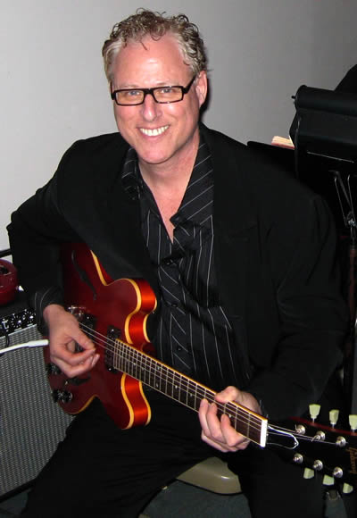Any form of expression, especially music, is an exercise in self-discovery. Determining what makes you unique is perhaps the most important aspect of personal development. Music and the arts help people find their unique “voice” in life rather than just going through the motions. There is perhaps no greater gift we can give our children than those tools of introspection. Also, in a global business world where access to information, technology, and resources is getting easier, differentiation is essential.

“Listening to, performing, discovering, feeling, and expressing music is almost like nature itself unfolding inside of you. To deny people that world of discovery seems to be bordering on criminal.”
President, Vineberg Communications,
Guitarist (recording and performing credits
include Whitney Houston, Carlos Santana,
& Narada Michael Walden)

Passion (Play it With Feeling)
Hand in hand with finding your unique talents is the discovery of your passions. We have too many people on the planet who are square pegs trying to fit into round holes. They have jobs and no purpose, a living but not a life, and they are avoiding the pursuits that they are uniquely qualified to offer to the world due to fear or complacency. Yet nothing great was ever achieved without passion.

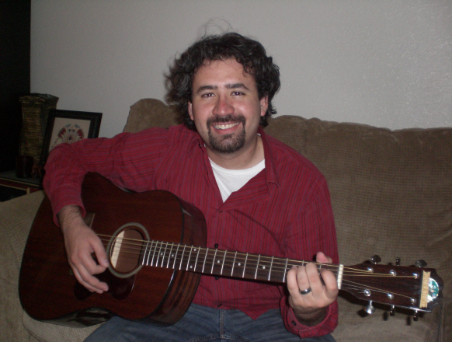“When it comes to success in business, the first place that people fall down and fail is by refusing to own up to their actual dream. Rock bands teach us that the actual dream is to be world famous. To play huge arenas and change people’s lives.”

“When people come to business, I wish more of them would say that. Your goal is to change the face of the world through what you do. If more people came to the table like 16 year-old rock musicians, they would find a lot more success and a lot more happiness in the success they find.”

Mark Truman, Executive Director & Founder,

Omniac Education
College entrance consulting, tutoring, and test preparation

Guitarist/Vocalist

About the Author
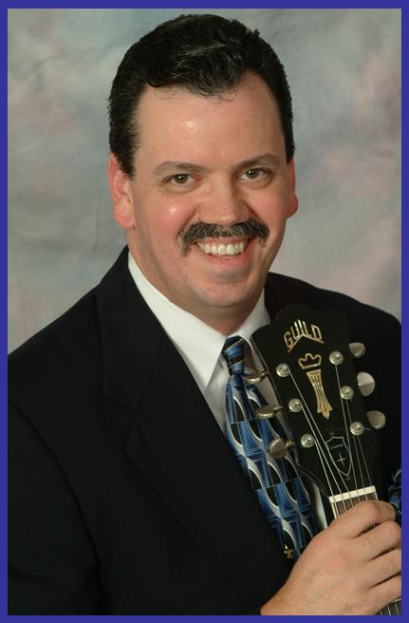Craig Cortello is a contributing music writer to Where Y’at magazine and AllAboutJazz.com, having had the pleasure of interviewing such New Orleans music icons as Pete Fountain, Ellis Marsalis, Jr., and Henry Butler. He is also a 30 year veteran of the guitar, a self-taught pianist, and a composer. In business, Craig most recently served as National Sales Manager of a successful environmental consulting firm with 28 offices in the U.S. and China. He is a board member of the National Speakers Association New Orleans chapter and of the Metairie Sunrise Rotary Club.

For additional information regarding this article and the book Everything We Needed to Know About Business, We Learned Playing Music, including speaking engagement requests, contact ccortello@LDV-Enterprises.com or visit www.BusinessMusician.com.

